DAD220

Professor Collins

Valerie Montalvo

5 December 2022

1. Begin by writing SQL commands to **capture usable data** (which you’ve preloaded into Codio) for your analysis.
2. Specifically, the product manager wants you to analyze the following:
   * 1. Analyze the number of returns by state and describe your findings in your report.

*Massachusetts has the most returns of the states at a total of 972, which is 98% of its total sales (988). Massachusetts also has the highest number of sales.*

* + 1. Analyze the percentage of returns by product type and describe your findings in your report.

*The ENT-48-10F has the largest return percentage of the products, but is followed closely behind by the rest.*

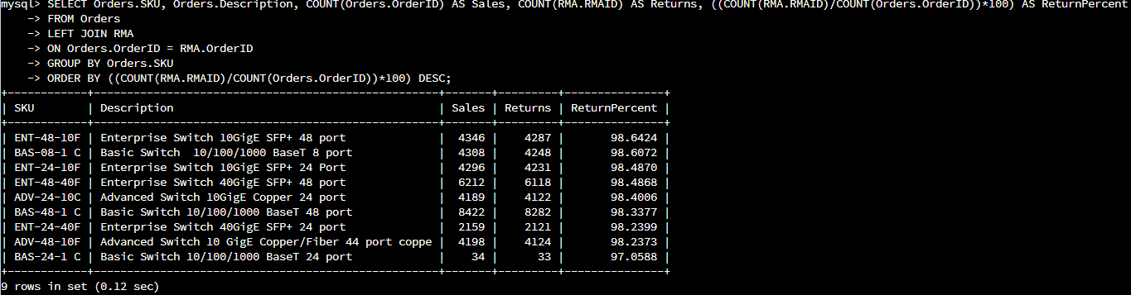

1. In your report, clearly summarize your analysis of the data for stakeholders.

Utilizing the data, I was able to find unfavorable trends in Quantigration’s returns that could signify heavy costs, both financial and with our customers. First, let’s start with sales. The first chart below (Figure 1) shows the overall concentration of sales in the US for Quantigration; the darker the color on the map, the more sales. As you can see, Massachusetts has our largest customer base with the most sales—a total of 988. On the other hand, Virginia is the only state in the country with no recorded sales.

Comparing Figure 1 with the next chart, which shows the concentration of returns in the US (Figure 2), we can see that the concentrations are almost identical.

Figure : Sales by State

Figure : Returns by State

The chart below (Figure 3) shows the total sales and returns, and the return percentage of each product. As we can see, Quantigration products have a 97-99% return rate of the total sales. This means that almost every product sold will return.

Figure : Overall Return Percentage by SKU

Now let’s look at why. The figures below (Figure 4 and 5) illustrate the reasons each product was returned and what percentage those reasons make up of the total returns per product, and overall. The percentages here are fairly evenly distributed between the three reasons in our system, with the product being incorrect the highest percentage by a slim margin.

Figure : Return Reasons % by SKU

Figure : RMA Reason Percentage

From our data, we can confidently conclude that the rate of returns is unacceptable at an astonishing 97-99%, and the reasons behind the returns should be investigated. However, there are questions that need to be answered before we can effectively establish root causes and work to improve them.

For example:

* What is the timeline of these returns?
* What falls under the ‘Other’ reason category?
* Were the ‘Incorrect’ returns due to customers ordering incorrectly, or was this on our end?
* Were the ‘Defective’ returns defective on arrival, or did they break over time?

Therefore, it is my suggestion that we expand our data to capture these gaps which we will then reevaluate for a more comprehensive analysis prior to any corrective action.